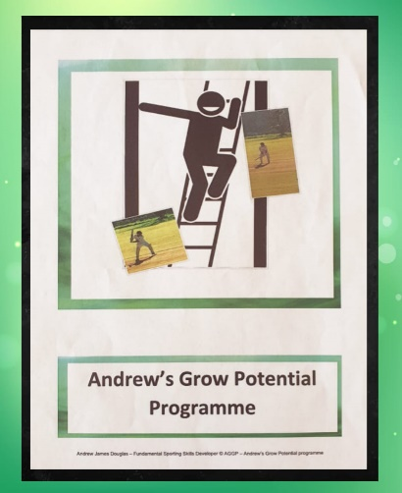

**ENROLMENT FORM**

**CHILD DETAILS**

FIRST NAME : SURNAME :

PREFERRED NAME : AGE :

DATE OF BIRTH : HOME LANGUAGE :

PARENT/GUARDIAN

|  |  |  |
| --- | --- | --- |
|  | **FATHER/GUARDIAN** | **MOTHER/GUARDIAN** |
| **TITLE** |  |  |
| **FIRST NAME** |  |  |
| **SURNAME** |  |  |
| **ID NUMBER** |  |  |
| **CONTACT NUMBER (HOME)** |  |  |
| **CONTACT NUMBER (WORK)** |  |  |
| **CELL PHONE NUMBER** |  |  |
| **HOME ADDRESS** |  |  |
| **POSTAL ADDRESS** |  |  |

**MEDICAL INFORMATION**

MEDICAL CONDITION :

ALLERGIES :

SPECIAL REQUIREMENTS :

DOCTOR :

CONTACT NO :

**PERSON RESPONSIBLE FOR PAYMENT**

TITLE :

FIRST NAME : SURNAME :

CONTACT NO (H) : (W) :

EMAIL ADDRESS :

HOME ADDRESS:

POSTAL ADDRESS:

**EMERGENCY CONTACT**

TITLE :

FIRST NAME : SURNAME :

CONTACT NO (H) : (W) :

EMAIL ADDRESS :

HOME ADDRESS:

POSTAL ADDRESS:

**TERMS AND CONDITIONS**

1. **Full payment is due prior to commencement.**
2. **Children should attend all sessions for the stipulated period.**
3. **Programme design is the property of** **Andrew’s Grow My Potential and may not be reproduced or utilized for any purposes other than as a participant in this programme.**
4. **This enrolment is non-transferable.**
5. **Payment is non-refundable.**
6. **Enrolment will be taken as confirmed once this completed form has been received by Andrew’s Grow My Potential and payment is received.**
7. **By enrolling your child/children, you agree to Andrew’s Grow My Potential to collecting, storing and processing names, contact details and information relating to yourself and your child/children, and to provide this information in class lists and to staff/responsible persons authorised by the Andrew’s Grow My Potential.**
8. **Only with permission of the parent/guardian will Andrew’s Grow My Potential include photographs (with or without name) of your child/children in relevant publications, on our website or social media sites, or in press releases, or any marketing information to celebrate Andrew’s Grow My Potential or your child's/children’s activities, achievements or successes.**

**ALTERNATIVE CONTACT**

(THAT DOES NOT RESIDE WITH CHILD)

TITLE :

FIRST NAME : SURNAME :

CONTACT NO (H) : (W) :

RELATIONSHIP:

**TERMS AND CONDITIONS**

I/we (parent guardian) hereby declare that I/we have read and understood the Terms and Conditions as stated in this Enrolment Form and agree to abide by these.

I/we hereby confirm that the information provided is correct in all material respects, and that nothing material has been omitted.

I/we grant permission for my/our child’s/children’s’ participation in Andrew’s Grow My Potential programme and agree to indemnify Andrew’s Grow My Potential and its representatives/staff/facilitators from any claims or law suits by myself/ourselves or the child or others, that arise from participation in the programme. I/we also agree to pay attorney’s fees, or any legal fees or expenses incurred in defense of such a claim/law suit.

FATHER/GUARDIAN

SIGNED at on 20

Name Signature

MOTHER/GUARDIAN

SIGNED at on 20

Name Signature